WDD 330 Week 4: Final Project Proposal
SmartAqua: ML-Driven Energy Optimization for Remote Aquaculture Filtration Systems
Your Name: Okoro, Osahon
Date: 6th June 2026

Section 1: Overview
Problem Statement
Traditional water filtration systems in aquaculture operate continuously, consuming large amounts of energy even when full treatment is unnecessary. Timer-based and manual controls lack adaptability. Manual water quality monitoring is labor-intensive, error-prone, and reactive rather than proactive. Machine learning models (ANN, SVM, DT) have demonstrated high accuracy in predicting water quality parameters. However, most existing frameworks focus solely on prediction without addressing energy optimization in filtration and sterilization processes. This creates a gap between monitoring and actionable control. Simulation-based studies have validated real-time sensing but remain limited to prototype environments without integration into deployable aquaculture systems. As a result, fish farmers face high operational costs, inefficient resource use, and elevated carbon footprints due to continuous energy-intensive filtration.

Current Solutions & Their Limitations
Solution | Limitation
Continuous pumps | Waste 30-40% electricity on unnecessary filtration
Handheld test kits | Expire in tropical heat; require literacy to interpret
Commercial IoT systems | Cost $2,000+ (4x monthly profit of small farm)
Research ML models | Predict but don't control pumps; lab-only validation

My Solution
SmartAqua is a web-based dashboard that visualizes real-time water quality data (temperature, pH, ammonia, dissolved oxygen) from IoT sensors or simulation. A Support Vector Machine (SVM) model classifies each reading as Safe, Moderate, or Hazardous based on FAO aquaculture thresholds. Filtration and UV sterilization activate only when needed - not continuously. The system operates on a duty-cycle basis: 0% during Safe conditions, 50% during Moderate, and 100% during Hazardous. This reduces energy consumption by an estimated 35% while maintaining optimal water quality. The system uses an ESP32 microcontroller for sensor data acquisition, a Raspberry Pi 4 for processing and machine learning inference, and Modbus TCP/IP for communication. All data is logged to localStorage, enabling offline functionality and CSV export for farmer records.
My Motivation
This project emerged directly from my PhD thesis research, which identified a critical gap in existing aquaculture literature: machine learning models achieve high accuracy in predicting water quality parameters, but almost none integrate those predictions into real-time control actions for filtration and UV sterilization. Most studies stop at classification accuracy (96-98%) without addressing energy optimization or physical deployment. SmartAqua serves as the practical, web-based implementation of my thesis framework - translating SVM-based predictions into duty-cycle pump control, energy savings visualization, and offline-capable monitoring. This project is not separate from my research; it is the deployment layer that makes my thesis actionable for smallholder farmers in Cross River State, Nigeria.

Section 2: Target Audience
Persona | Description | Primary Goal | How App Serves Them
Smallholder Farmer (Amaka, 35) | Rural Cross River, basic smartphone, 1-2 ponds | Reduce electricity bills, prevent fish kills | Color-coded dashboard (green/yellow/red), SMS alerts, works offline
Commercial Farm Manager (Mr. Eyo, 50) | Peri-urban Akwa Ibom, 10+ ponds, some computer experience | Lower operational costs, generate investor reports | Energy savings dashboard, historical trends, CSV export
Industry Investor (Mrs. Ngozi, 45) | Lagos, high tech comfort, supports agribusiness startups | Identify cost-saving, scalable ventures | kWh reduced display, multi-farm architecture
Researcher (Dr. Adewale, 40) | SW Nigeria university, publishes in precision aquaculture | Obtain deployable framework for teaching/research | Open methodology, SVM code, hardware diagrams

Section 3: Major Functions
# | Function | Description
1 | Real-time multi-zone sensor display | Live readings for temperature, pH, ammonia, DO across 4 pond zones. Updates every 10 seconds without page refresh.
2 | SVM-based water quality classification | SVM model (trained on 7,556 records) classifies as Safe/Moderate/Hazardous based on FAO thresholds. Runs in JavaScript instantly.
3 | Color-coded visual alert system | Status badges on each card. Hazardous triggers red flashing border + browser notification. Alerts persist until 3 consecutive safe readings.
4 | Energy savings estimator | Calculates baseline (1.20 kWh/day continuous) vs optimized (duty-cycle based). Displays savings in kWh and ₦.
5 | Duty-cycle filtration control | Pump: 0% duty (Safe), 50% (Moderate), 100% (Hazardous). UV: active only during Hazardous. Control signals to GPIO relay module.
6 | Historical data logging with localStorage | Saves all readings to localStorage (1,000 entry cap). View, filter, export CSV. Works completely offline.
7 | Simulation mode for testing & training | Six preset scenarios + manual sliders. Same threshold logic as production. No risk to live fish.
8 | Mobile-responsive layout | Desktop (2×2 grid), tablet (2×2 smaller), mobile (stacked). 44×44px touch targets. Hamburger menu below 768px.

Section 4: Wireframes

View | Platform | Wireframe/Description
Main Dashboard | Desktop | 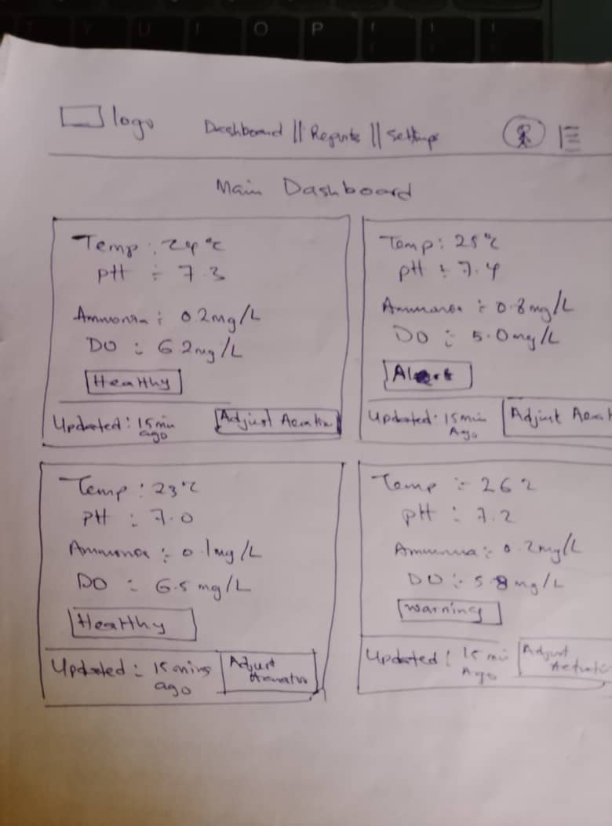  2×2 grid of pond cards: temperature, pH, ammonia, DO, status badge, timestamp, manual override buttons
Main Dashboard | Mobile | 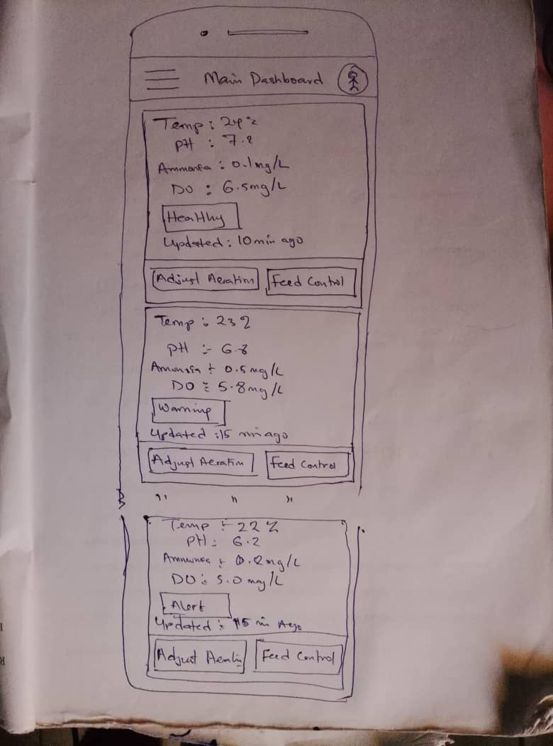  Stacked cards, hamburger menu, simplified layout, 44×44px touch targets
Simulation View | Desktop | 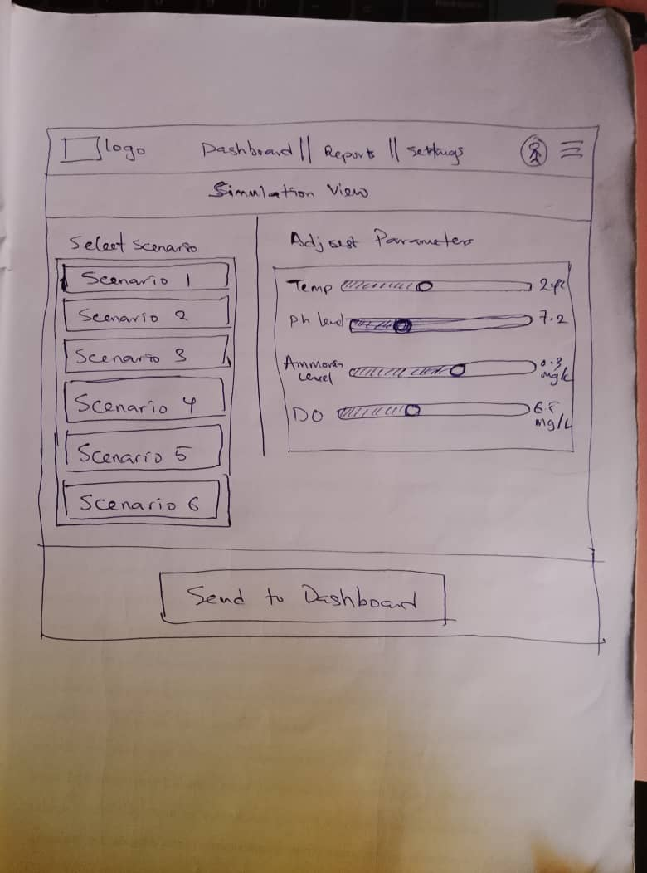  Scenario buttons (6 presets), manual sliders for each parameter, "Send to Dashboard" button
History/Logs | Desktop | 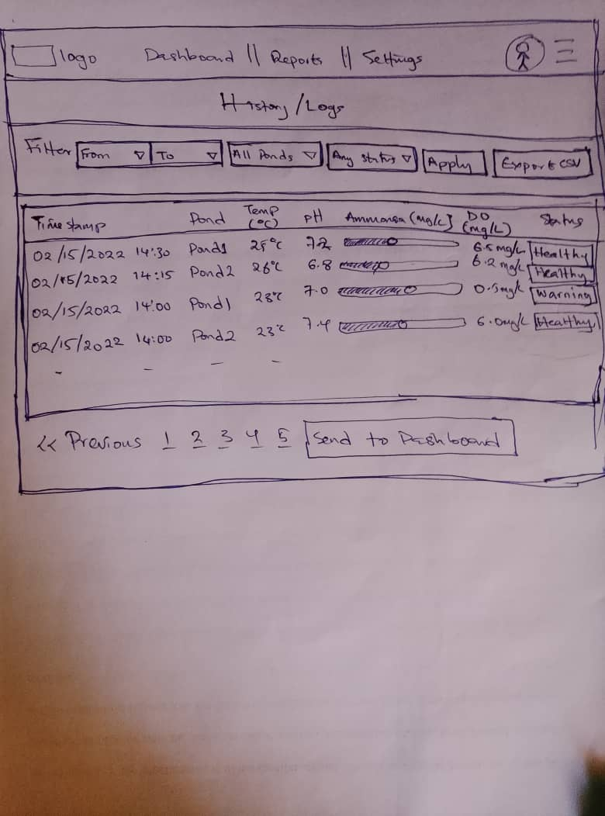  Table of past readings: timestamp, pond, temp, pH, ammonia, DO, status. Filter controls. Export CSV button

Section 5: External Data
API #1: ThingSpeak IoT Platform
Specification | Detail
What it is | IoT cloud platform by MathWorks for time-series sensor data
Endpoint (read) | https://api.thingspeak.com/channels/[CHANNEL_ID]/feeds/last.json
Data provided | Temperature (°C), pH, ammonia (mg/L), DO (mg/L) with timestamps
How I use it | Dashboard fetches last 20 readings every 10 seconds using fetch()
Free tier | 3 million requests/year, 4 free channels

API #2: USGS Water Quality Data
Specification | Detail
What it is | USGS National Water Information System - real water quality from monitoring stations
Endpoint | https://waterservices.usgs.gov/nwis/iv/?format=json&sites=01646500&parameterCd=00010,00020
Parameter codes | 00010 = Temperature, 00020 = pH, 00300 = Dissolved Oxygen
How I use it | Fetch reference water quality data to validate classification thresholds
Free tier | Unlimited public data, no API key required

Local Storage (No API Required)
Data Type | Storage Method | Purpose
Recent sensor readings | localStorage (sensorHistory) | Offline access, trend analysis (1,000 entries max)
User preferences | localStorage (userSettings) | Alert thresholds, refresh rate
Saved simulation scenarios | localStorage (savedScenarios) | Replay test cases across sessions

Section 6: Module List
Project Structure
js/ #This is the main folder while the sub-directories are listed below:
- main.js # Entry point: initializes modules, starts polling

- api/ #Api folder
- thingspeak.js # Fetch sensor data from ThingSpeak
- usgs.js # Fetch reference data from USGS

- core/ # folder
- classify.js # SVM/threshold classification → Safe/Moderate/Hazardous
- energy.js # Calculate energy savings (baseline vs optimized)

- ui/ #folder
- dashboard.js # Render pond cards, update values without refresh
- alerts.js # Check thresholds, trigger visual flash + notifications
- history.js # Save to localStorage, load history, export CSV
- simulation/ #folder
- simulator.js # Generate mock data (6 scenarios + manual sliders)
- utils/ #folder
- storage.js # localStorage wrapper with error handling
- helpers.js # formatTimestamp(), debounce(), average()

Module Descriptions
Module | File | Key Functions | Description
Entry Point | main.js | initApp(), startPolling() | 10-second refresh, visibility handling
ThingSpeak API | thingspeak.js | fetchReadings(), handleError() | HTTP GET, retry on failure
USGS API | usgs.js | fetchReferenceData(), parseParameterCodes() | Real water quality reference
Classification | classify.js | classifyReading(), getThresholds() | FAO-based thresholds
Energy Calculator | energy.js | calculateSavings(), formatCurrency() | Baseline 1.20 kWh/day vs optimized
Dashboard Renderer | dashboard.js | renderCard(), updateCardValue() | Updates individual fields without full re-render
Alert Manager | alerts.js | checkThresholds(), sendNotification() | Browser Notification API, 3-reading cooldown
History Module | history.js | saveReading(), exportToCSV() | localStorage ring buffer (max 1000)
Simulator | simulator.js | generateScenario(), startSimulation() | Six preset scenarios
Storage Wrapper | storage.js | setItem(), getItem(), clearOldReadings() | localStorage abstraction, quota handling
Helpers | helpers.js | formatTimestamp(), debounce(), average() | Pure utility functions

Section 7: Graphic Identity
Color Palette
Role | Color | Hex | Usage
Primary (brand) | Dark Teal | #0D5C46 | Headers, navigation, primary buttons
Secondary (accent) | Amber | #F4A261 | Icons, hover states
Background | Light Gray | #F8F9FA | Main page background
Card background | White | #FFFFFF | Pond cards
Text primary | Dark Gray | #212529 | Body text
Safe status | Green | #28A745 | "Safe" badge
Moderate status | Yellow | #FFC107 | "Moderate" badge
Hazard status | Red | #DC3545 | "Hazard" badge, flashing borders

Typography
Element | Font | Fallback | Size
Headings | 'Poppins' | sans-serif | 24-32px
Body text | 'Inter' | sans-serif | 14-16px
Sensor values | 'Inter' | monospace | 18-24px

Application Icon
Dark teal (#0D5C46) circular background. White water droplet with wave line (three curved arcs). Small green leaf sprouting from top. Scalable.

Section 8: Timeline - Weeks 5-7
Week 5: Foundation & Static Dashboard
Day | Task | Est. Time
Mon | GitHub repo; folder structure; index.html | 1 hr
Tue | Static HTML/CSS: 4 pond cards (2×2 grid) | 2 hr
Wed | Responsive CSS: media queries for tablet/mobile | 2 hr
Thu | Mock data object; render to cards | 2 hr
Fri | Timestamp display; setInterval refresh (10 sec) | 1.5 hr
Sat | Classification function (FAO thresholds) | 2 hr
Sun | Cross-browser test; GitHub Pages deploy | 1 hr

Week 6: Core Logic & API Integration
Day | Task | Est. Time
Mon | ThingSpeak channel; fetchReadings() function | 2 hr
Tue | Energy calculator: baseline vs optimized | 2 hr
Wed | localStorage history; history modal | 2 hr
Thu | Simulation mode: 6 scenarios + manual sliders | 2.5 hr
Fri | Manual override buttons (Pump/UV) | 1.5 hr
Sat | USGS API integration | 2 hr
Sun | Cross-browser test; deploy updates | 1.5 hr

Week 7: Polish, Testing & Deployment
Day | Task | Est. Time
Mon | Browser notifications on Hazardous state | 1.5 hr
Tue | CSV export from localStorage | 1.5 hr
Wed | Error handling: API fallback to cached data | 2 hr
Thu | Accessibility audit: WCAG AA, ARIA labels | 2 hr
Fri | Performance: debounce API calls, minify | 1.5 hr
Sat | README.md; inline code comments | 1.5 hr
Sun | Final GitHub Pages deploy; submit | 0.5 hr

Section 9: Trello Board (1/2 page)
Trello Board Link: https://trello.com/b/ugV8wxnr/wdd-330-final-smartaqua
Lists: To Do | In Progress | Done
Required Cards (30+):
- Setup (5 cards): Create GitHub repo, folder structure, index.html, link CSS/JS, test live server
- Dashboard UI (7 cards): 4 pond card containers, CSS Grid (2×2), mobile media queries, status badges, timestamp, navigation bar, 44×44px touch targets
- Mock Data & Classification (5 cards): Mock data object, render function, setInterval refresh, classification thresholds, test edge cases
- API Integration (6 cards): ThingSpeak account, channel with 4 fields, fetchReadings(), USGS API, parse parameter codes, error handling
- Core Features (7 cards): Energy calculator, localStorage history, history modal with filters, simulation mode (6 presets), manual sliders, override buttons
- Polish (6 cards): Browser notifications, CSV export, API error fallback, accessibility audit, README.md, final deploy

Section 10: Anticipated Challenges
Challenge | Severity | Mitigation Strategy
- No physical sensors (simulated data) | Medium | ThingSpeak with manually uploaded test data + simulation module. Real sensors (ESP32 + probes) would replace simulated data in production.
- Internet connectivity in rural farms | Medium | Offline-first architecture: localStorage caches last 200 readings. Dashboard usable with cached data when offline. SMS/GSM fallback for future work.
- Farmer literacy and accessibility | Medium | Color-coded status (red=bad, green=good) as primary communication. Icons alongside text. Minimal reading level design.
- Classification thresholds (Safe vs Hazardous) | Low | Thresholds from FAO aquaculture guidelines: DO >5 = Safe, <3 = Hazardous; NH₄⁺ <0.5 = Safe, >2 = Hazardous; pH 6.5-8.5 = Safe, <6 or >9 = Hazardous. Documented in code.
- USGS API returns different units | Low | USGS temperature in °C (good). DO may be mg/L or % saturation. Helper function normalizeUSGSReading() standardizes before classification.
- ThingSpeak rate limiting | Low | Poll every 10 seconds (free tier allows 1 write per 15 sec, reading more generous). Conditional fetching (only if tab visible).
- Real-time latency with HTTP polling | Low | 10-second latency acceptable for aquaculture (fish don't need millisecond response). Future: MQTT for sub-second latency.

